Class Flow
Show example: https://catango88.github.io/CTK-Portfolio/
- Create a new folder on your computer to save all of your work CTK-Portfolio
- Open VS Code
- Navigate to File -> Open Folder -> CTK-Portfolio
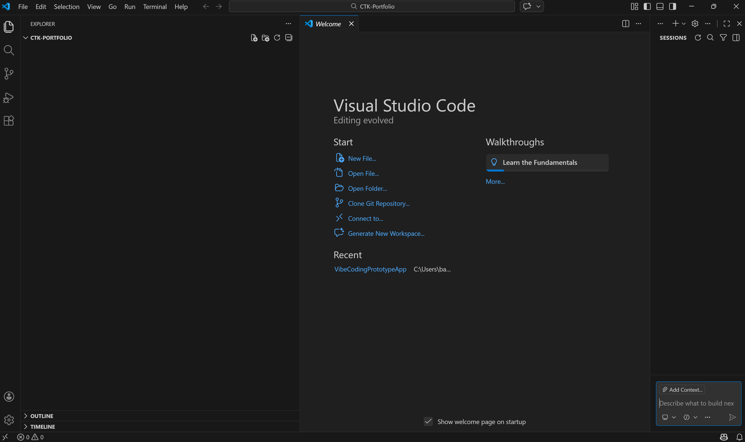
- Inside VS Code, create a new file: index.html
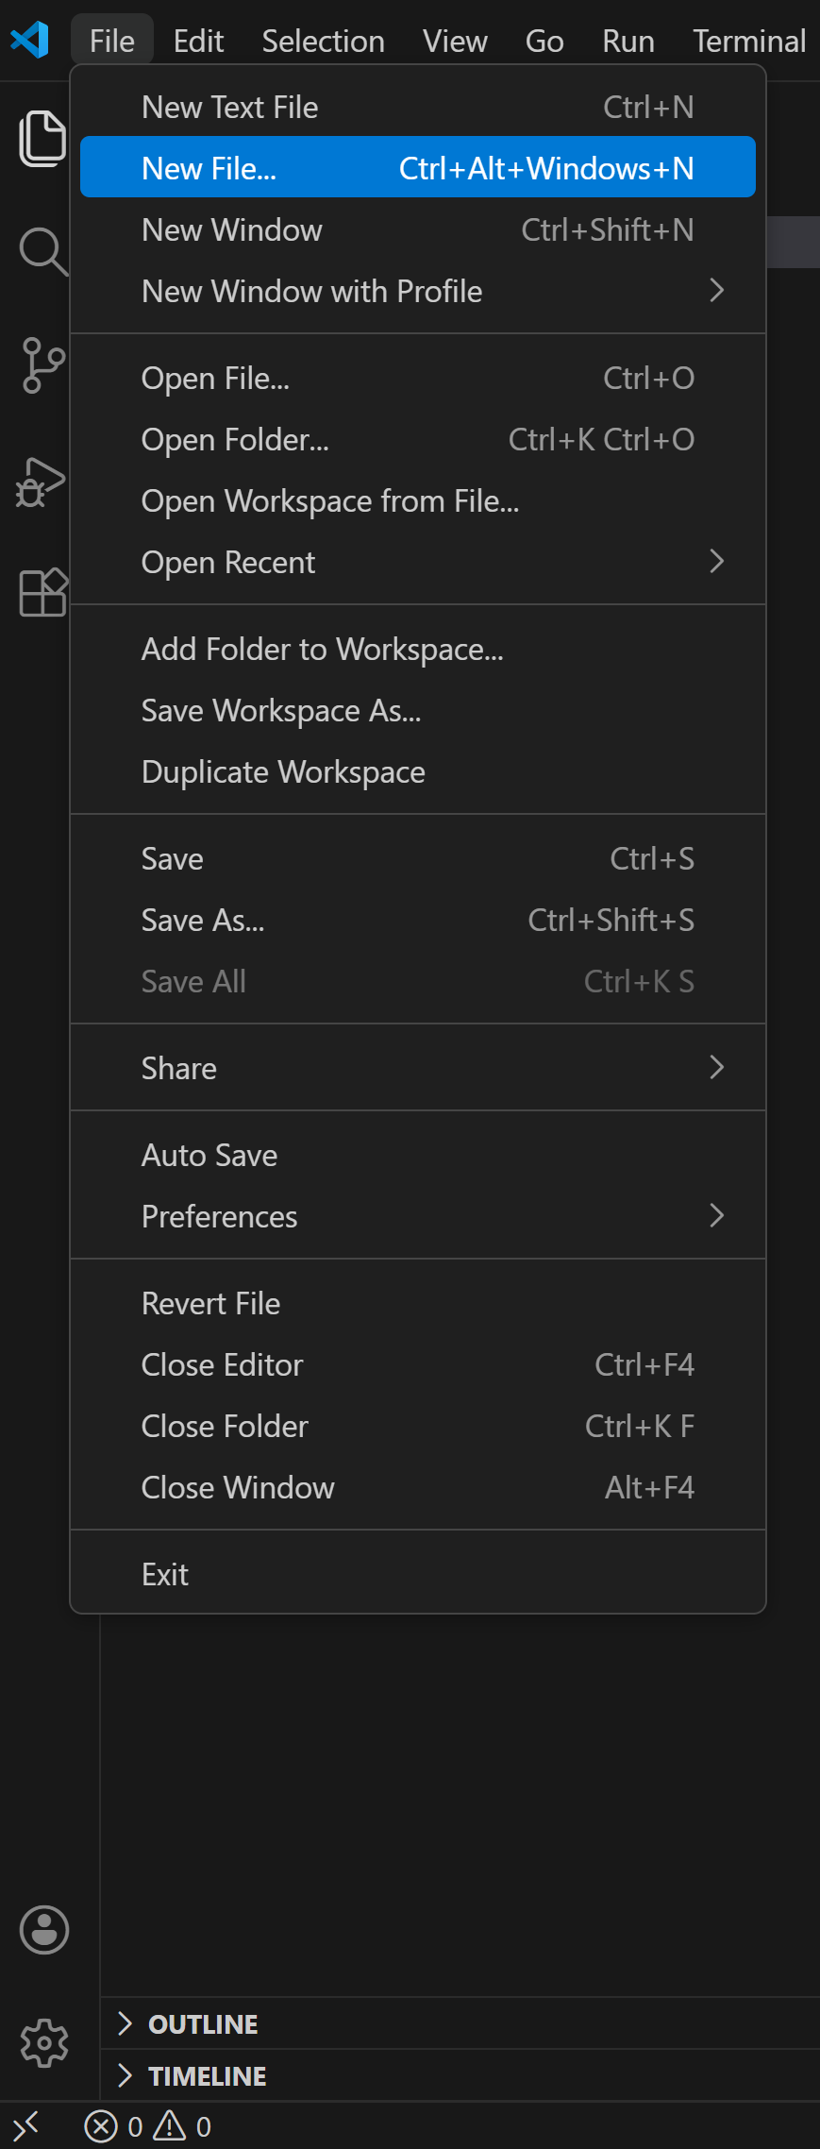
- Open CoPilot Chat. If CoPilot Chat isn’t open in the right sidebar, open it by clicking the speech bubble in the top nav bar. 

- In the chat, enter your prompt based on your Vibe Worksheet. Important: Start with “Create…” and end with “Return the full HTML document.” You can use the following as a model prompt:
Create a clean, modern, single-page portfolio website using only HTML and internal CSS (inside a <style> tag).
Requirements:
Name: Carolyn Tang Kmet
Tagline: Shaping the future of marketing through people and technology.
Sections:
- About
- Projects
- Contact
Design direction:
- Minimal, editorial, modern
- Emphasize whitespace
- Classic serif + sans-serif typography pairing
- Structured layout
- Neutral color palette (white, soft gray, near-black)
- Use Northwestern purple (#4E2A84) as a subtle accent color
- No gradients
- No stock images
- No heavy startup-style visuals
- Subtle hover effects
- Smooth scrolling navigation
- Fully responsive
- Clean top navigation with anchor links
- Prominent LinkedIn link: https://www.linkedin.com/in/ctkmet/
Content:
- Write a thoughtful About section (100–120 words) emphasizing interdisciplinary leadership, innovation, people-first technology, and marketing transformation.
- Create 3 placeholder project cards with titles and short descriptions.
- Keep layout centered with a max-width container.
Return the full HTML document.

- Save.
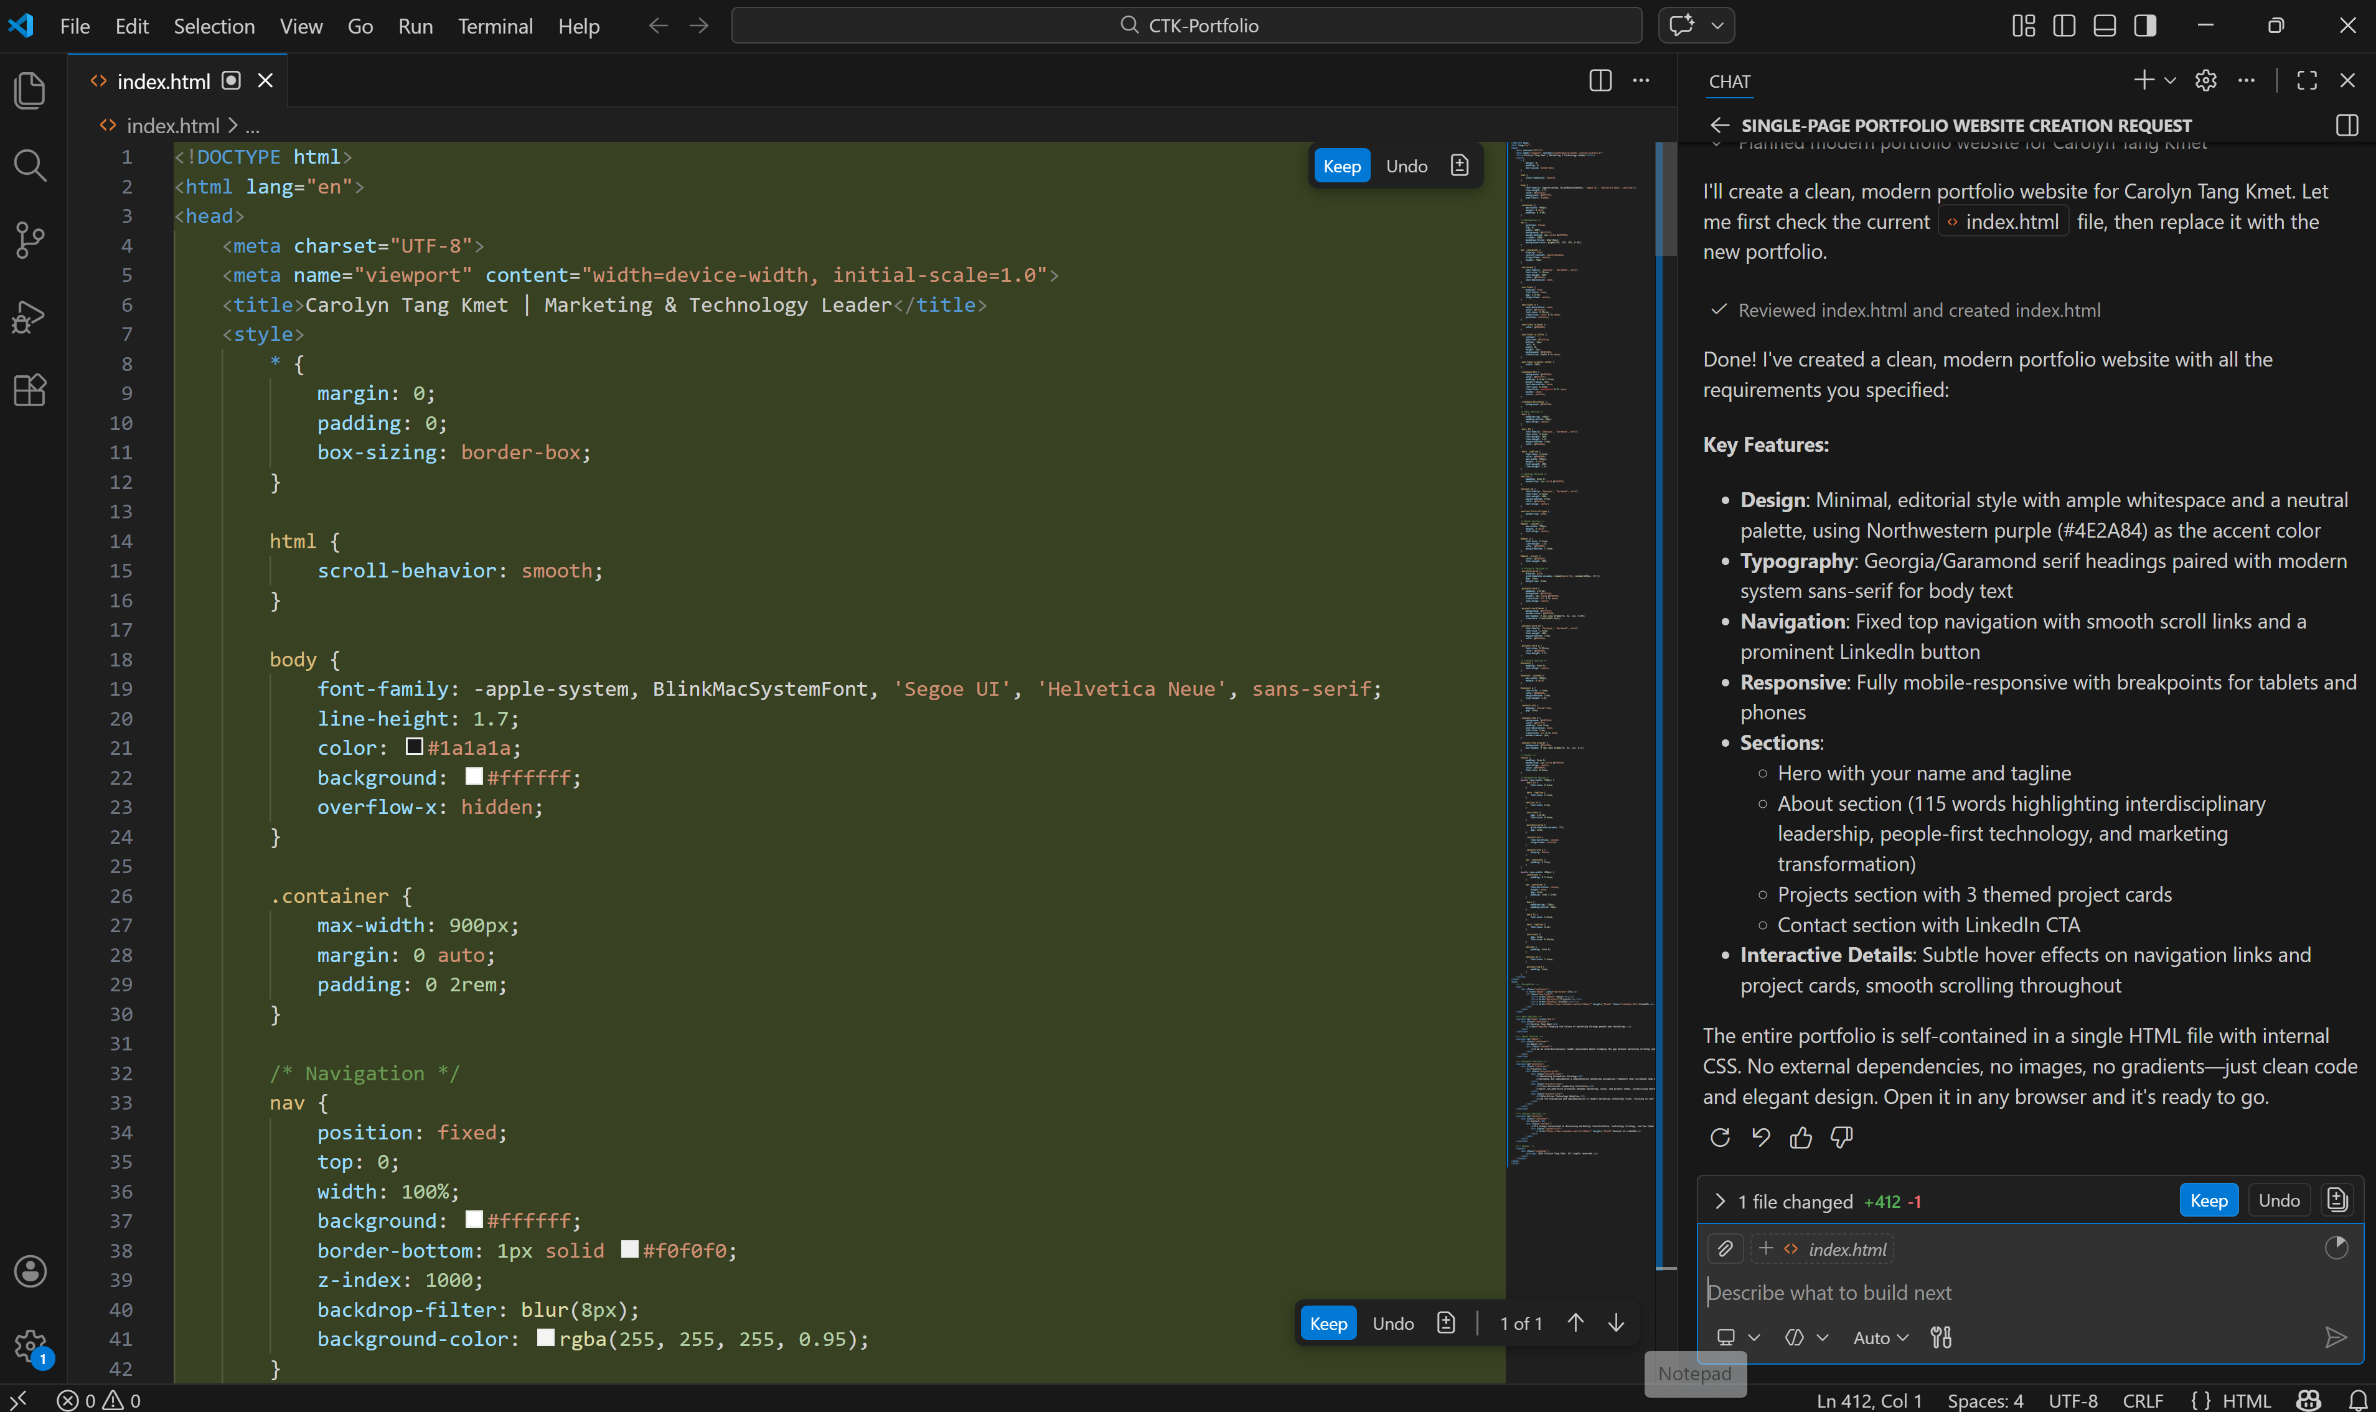

- Preview your site locally by navigating to index.html on your computer and opening it in your browser.

- Copy and layout changes you can make right in the chatbot. Things you might try:
- Add a headshot.
- Add a pull quote.
- Add a hero project.
- Add images to your project cards.

- To add images:
a) In the left nav bar, navigate to the file explorer 
b) Click the New Folder icon and create a new folder called Images 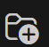
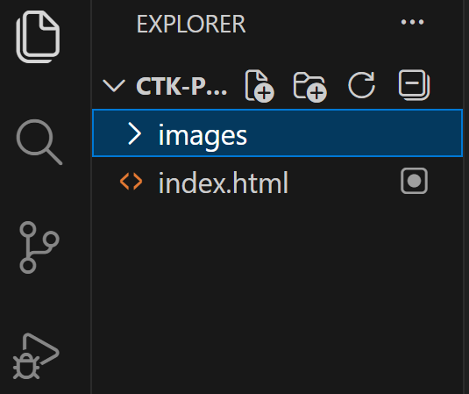
c) Drag images into that folder
d) Example prompt: Update the About section to include a center-aligned circular headshot image. Use the image path images/ctk_headshot.jpg.

- To publish, initialize Git by clicking the Source Control icon in the left sidebar , then selecting Initialize Repository.

- Under Changes, you’ll see all of your files. Hover over them and you’ll see a + sign. Click the + sign to add them to Staged Changes. Add a comment, such as “Version 1.0” or “Updated Headshot 3.4.26,” etc. Click Commit.
If you get a “Make sure you configure your user.name and user.email in Git” message, close and re-open VS Studio. Then navigate to Terminal/New Terminal, and paste:
git config --global user.name "Carolyn Tang Kmet"
git config --global user.email carolyn.kmet@northwestern.edu

- Click Publish Branch. MAKE SURE TO PUBLISH TO PUBLIC REPOSITORY
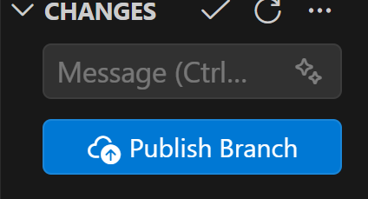

- Go to GitHub.com, open your new repository 
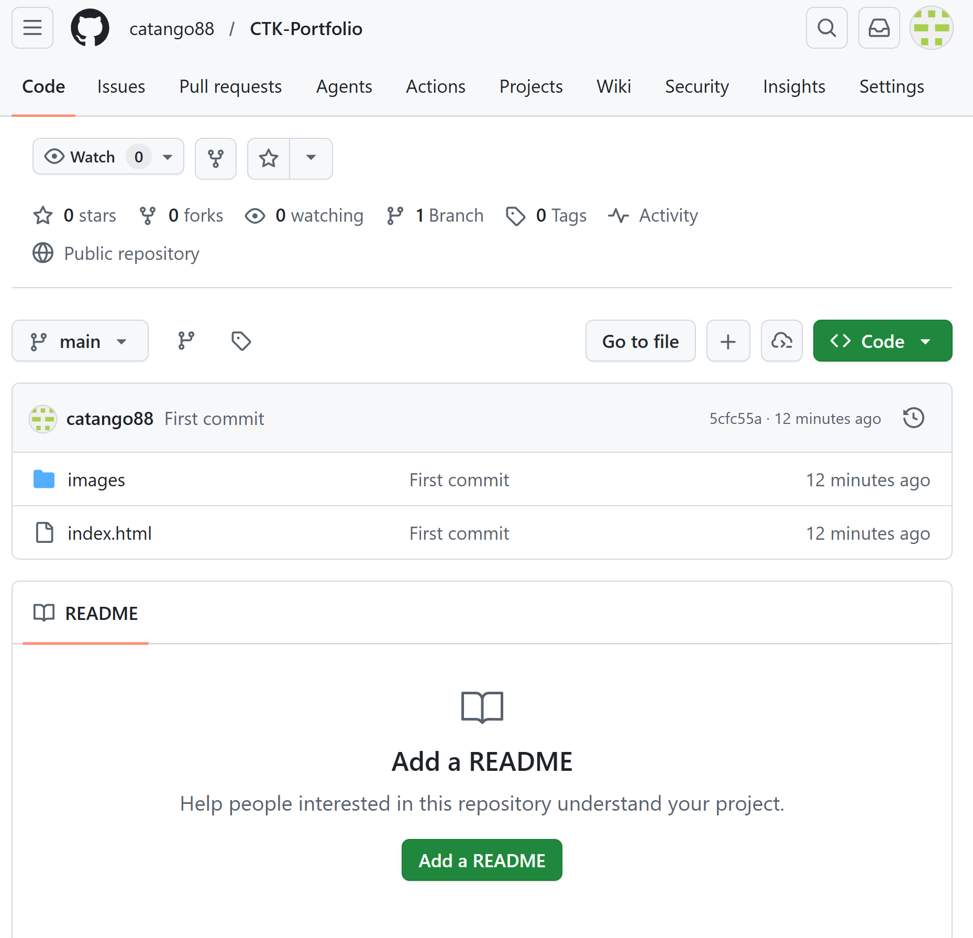
- Click Settings/Pages
- Under “Build and Deployment”:
  - Source: Deploy from a branch
  - Branch: main
  - Folder: /root

